**Learn WIth Online Soceity**

This is the main goal of my project:

1. database design (using oracle plsql)
2. login logout with Java Script validation
3. using ajax to interactive in email + user_name+Password number. ( if email or unser name already have then no allow to continue)
4. how to post as public post.
5. How to upload photo with content .
6. how to follow each other
7. Notification system.
8. how to select a each category to get all post about it.
9. Like agree

We want to make a website which will be like as combination of blog site and forum site.

1. In this website the owner will publish his posts about his relevant topics.
2. There will be a Colum which will represent the topic of posts.
3. User can ask question about any post and also can share their opinion about any post or they can write about any new topics. User can also ask any question about new topics. They can also edit and delete their posts.
4. So there will be registration system to create user id.
5. But guest user can see every post, question and opinion but not see anybody profile.
6. User can follow each other to see each other’s profile and all questions or opinions.
7. User can comment each other’s question/opinion. And can agree or disagree about any opinions.
8. Questions and opinion will different color.
9. If any good opinion can get 10 numbers of AGREE then the opinion will be automatically go to main post .
10. There will be a pin post which will set by admin/owner of this website.
11. Every user have a profile which will contain with users all registration info and question/opinions one by one.

We will also try to include some other functions relevant this website and try to make it more gorgeous. And try to update in future.

Very soon I will show you my **database** plan of this project.  
  
Thank You.

Entity-Relationship Diagram 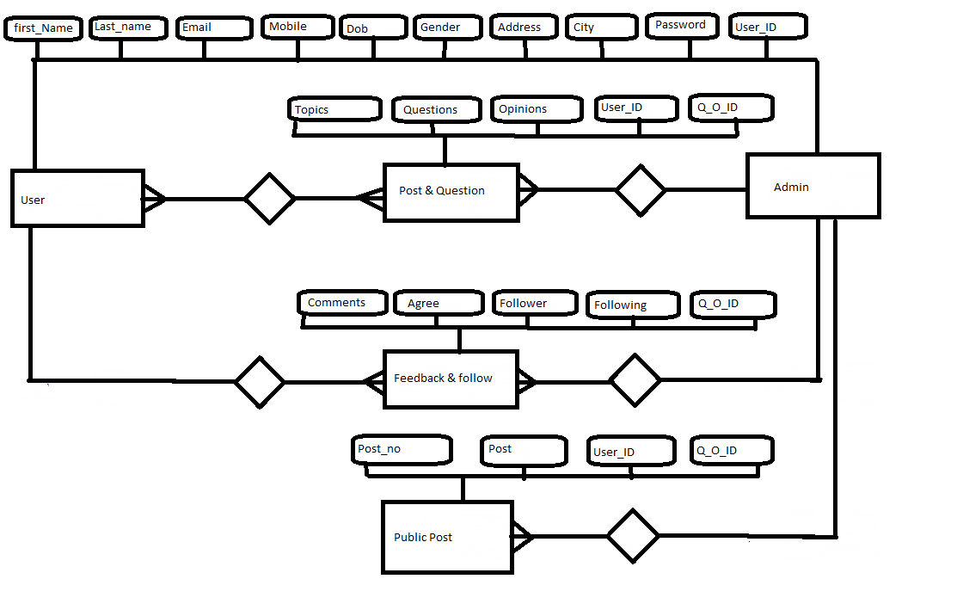 Activity Diagram

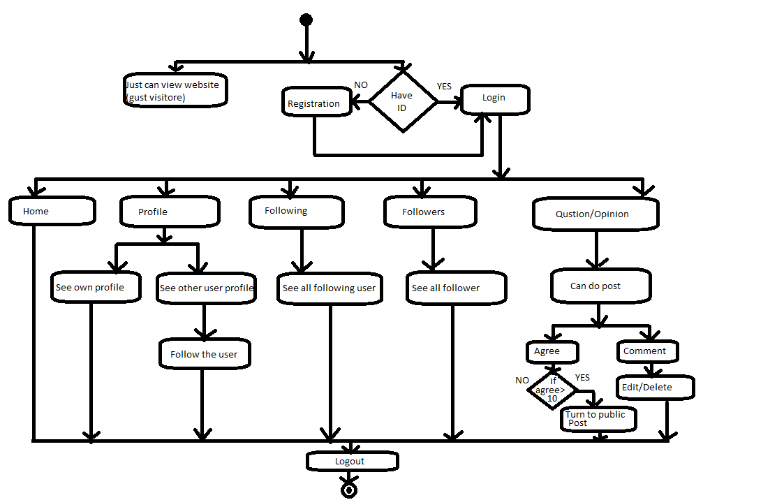

Use Case Diagram

